Molecular Reactions

This document describes design decisions made on 9/21/2006 by Linda Koch, Trish Loeblein, Kathy Perkins and Ron LeMaster

Simple Module
The general appearance of the module is shown in this drawing.
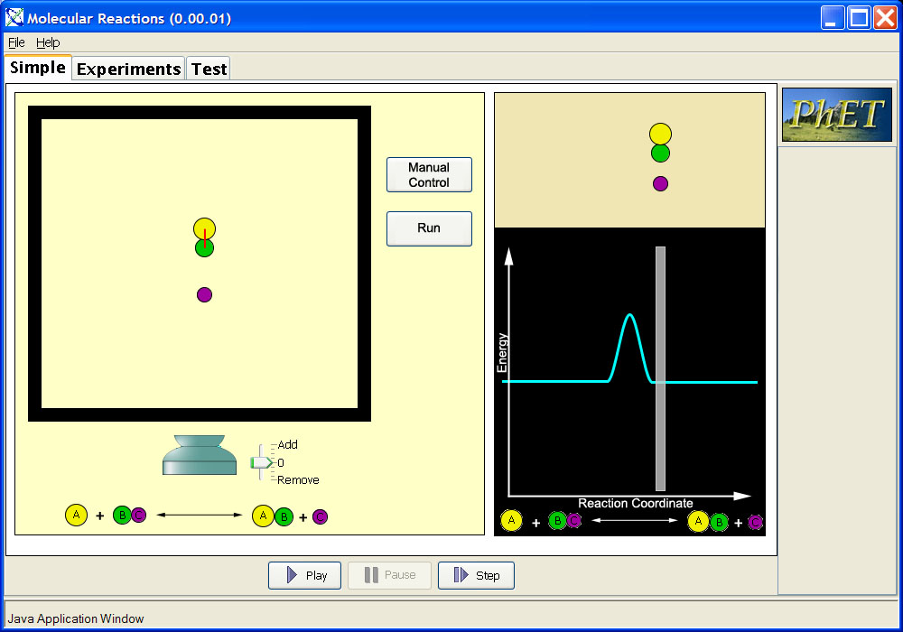
The left pane, the spatial view, will be narrower than show in this image, and the energy view will be wider.
The first module with have just three bodies. There will be no controls for adding or removing any bodies.
The bodies will move vertically in the middle of the box, rather than horizontally.
There will be a button that will enable the user to enter a manual control mode in which he or she will be able to move the gray bar in the energy view left and right. This will move the bodies closer and farther apart, and to one side of the reaction to the other. In the manual control mode, the user will also be able to drag any of the bodies in the box with the mouse up and down.
There will be another button that will set the simulation in the normal run mode.
There may be a mechanism for allowing the bodies to move in two dimensions rather than strictly up and down. (This is a definite capability, not just a maybe. In this mode the user should still be able to grab and move the atoms).

Multiple Body Module
The general appearance of the module is shown here.
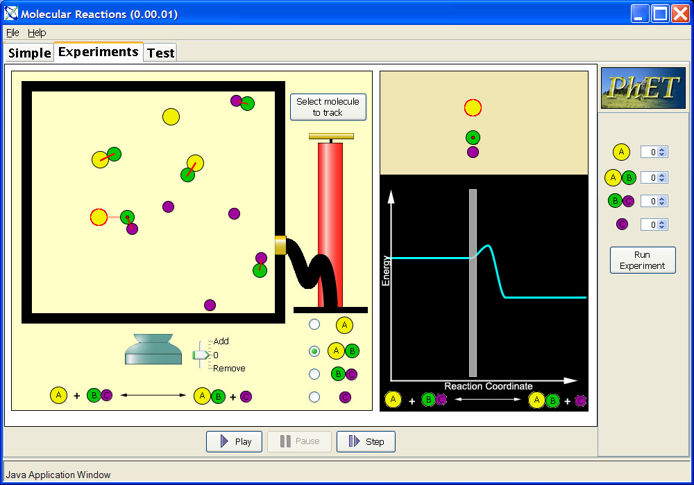
The user-selected body will be marked with a halo. The body nearest to the selected body that can react with the selected body will be marked by a dot.

Change the order of the molecules for selection to A then BC then AB then C. (If you can make them smaller under the pump that would be good).

Until a molecule is selected, the upper right pane will be empty and the grey marker will be gone.
There will be a control that is something like:
- Identify nearest neighbor. When this is checked, nearest neighbor will be marked, when it is not, nearest neighbor will not be marked.

The run, set up, stop should be changed to a run – stop control (this basically allows them to pause as well) but allows them to continue on in their experiement if they want. There should be a clear atoms button, and a reset all button.

Features Common to All Modules

Energy View Panes
The two panes in the energy view (the panes to the right in the play area) will be set off more distinctly from each other with borders, and will have a frame around them both. (Not sure exactly what this means so perhaps a mock up).
Trish: There needs to be a label on the pane above the energy graph. We talked about it denoting the relative position with a double arrow that grows and shrinks with the max distance.

Bond Depiction
Bonds will be shown by lines drawn on top of the bodies participating in the bonds.
(The atoms in the upper panel of the energy view panes, will also show the bonds, and will also show the selected molecule as having a hallow around it).

Energy Profile Manipulation
The user will be able to adjust with the mouse the sloping sides of the hump in the energy profile. Each side will be independently adjustable. When adjusted, the sloping side being adjusted will snap to the nearest of three positions. The positions will be determined by points spaced evenly along the profile as shown by the short beige lines in the following image. Note that these lines won’t appear on the screen. They are shown here only to depict where the snap-top points will be.
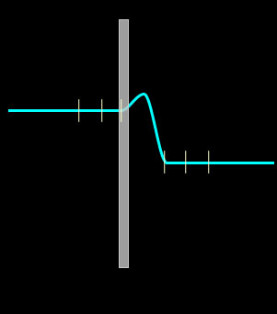
We might add a faint dashed grey grid to this.

TOTAL ENERGY, should be plotted on the energy plot. And this plot needs a legend for potential energy and total energy. The total energy line will be moveable up and down in the “Manual Mode”.

Do we want to put little manipulation arrows on this curve as we have in Bound states?

